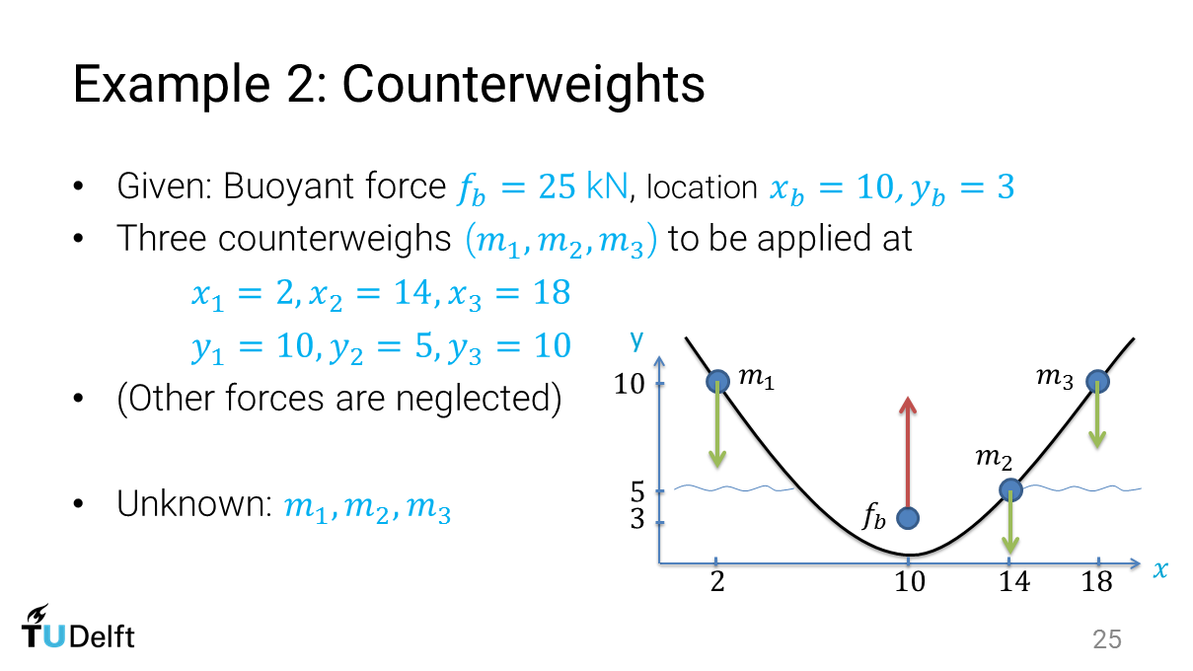

The optimization is formulated as

Min: $c_{y}(m_{1}, m_{2}, m_{3})=\frac{m_{1}y_{1}+m_{2}y_{2}+m_{3}y_{3}}{m_{1}+m_{2}+m_{3}}$

S.t. $c_{x}=\frac{m_{1}x_{1}+m_{2}x_{2}+m_{3}x_{3}}{m_{1}+m_{2}+m_{3}}=x_{b}$

($m_{1}+m_{2}+ m_{3})g=f_{b}$

$$m_{1}, m_{2}, m_{3}≥0$$

Since the second constraint reads ($m_{1}+m_{2}+ m_{3})g=f_{b}$, i.e., $m_{1}+m_{2}+ m_{3}=f_{b}\frac{1}{g}$, the first constraint can be rewritten as

$$m_{1}x_{1}+m_{2}x_{2}+m_{3}x_{3}=x_{b}f_{b}\frac{1}{g}$$

The left part becomes linear regarding the design variables $(m_{1}, m_{2}, m_{3})$.

Substituting the digital values into optimization problem, we get

Min: $c_{y}(m_{1}, m_{2}, m_{3})=\frac{{10*m}_{1}+{5*m}_{2}+{10*m}_{3}}{m_{1}+m_{2}+m_{3}}$

S.t. $2*m_{1}+14*m_{2}+18{*m}_{3}=10*25*{10}^{3}\frac{1}{10}=25000$

(Assuming $g=10m/s^{2}$)

$$m_{1}+m_{2}+ m_{3}=\frac{f_{b}}{g}=\frac{25*{10}^{3}}{10}=2500$$

$$m_{1}, m_{2}, m_{3}≥0$$

The matrix form of the two linear equality constraints is

$$\left(\begin{aligned}2 14 18 \\ 1 1 1\end{aligned}\right)\left(\begin{aligned}m_{1} \\ m_{2} \\ m_{3}\end{aligned}\right)=\left(\begin{aligned}25000 \\ 2500\end{aligned}\right)$$

Aeq = $\left(\begin{aligned}2 14 18 \\ 1 1 1\end{aligned}\right)$

Beq = $\left(\begin{aligned}25000 \\ 2500\end{aligned}\right)$

We create a function to evaluate the objective.

function f = exampleweights(m)

f = (10\*m(1) + 5\*m(2) + 10\*m(3)) / (m(1) + m(2) + m(3));

The above two lines are saved as exampleweights.m

Note: The m file shall have the same name as the function.

Now we have all the necessary information for the Optimization Toolbox.

Open the Toolbox by typing optimtool in the Matlab command window.

The screenshot in Matlab Optimization Toolbox looks like

